|  |
| --- |
| **Design:**  - keyed shaft: 8x32x35 DIN/ISO 14;  - pressure line: G1/2” DIN/ISO 228;  - suction line: G3/4” DIN/ISO 228;  - clockwise and counterclockwise rotation  **Working displacements:** 12, 17, 25, 28, 34, 80 cc |

**Analogues:**

F1 (Parker Hannifin)

A17FO (Bosch Rexroth)

SC, SCP, SAP (Sunfab)

HDS, MDS, HDT (OMFB)

xPi (Hydro Leduc)

FR (Bezares)

BI (Aber)

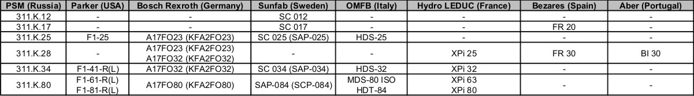

**Technical characteristics:**

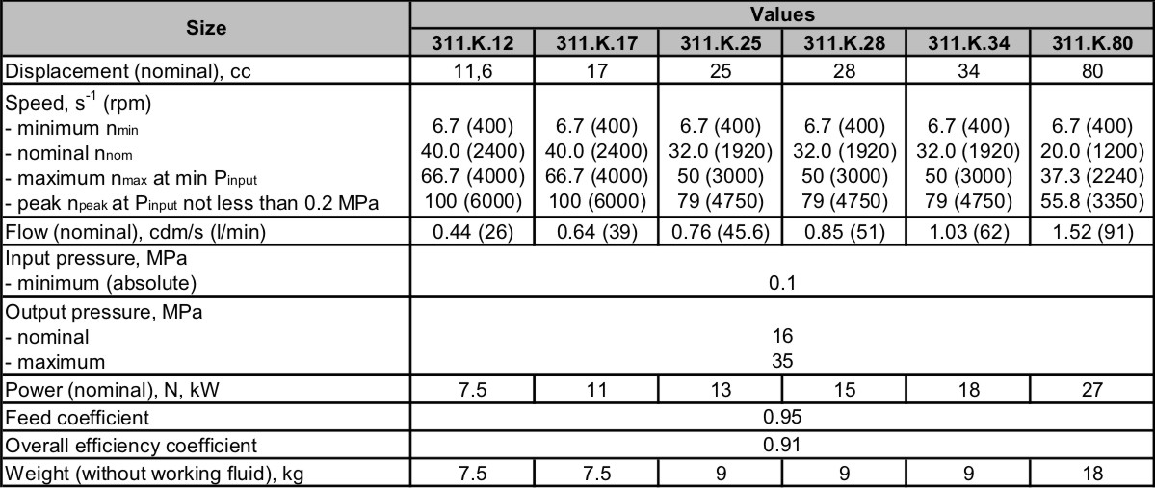

**Application:**

Pumps are intended for hydraulic circuits of mobile machines. Can be mounted directly on power take-off (PTO) or drive shaft of mobile machines.

**Advantages:**

- maximum pressure up to 35 MPa;

- compact size and light weight;

- easy installation;

- improved reliability

**Options available upon agreement with the customer:**

- complete set delivery “Pump + PTO”;

- mounting flanges as per ISO, GOST, DIN;

- delivery of suction line hoses, pressure line fittings, spare parts & accessories;

- vertical and horizontal orientation of the pump